CS2220 Introduction to Computational Biology
Assignment #3
Please submit to Prof Wong Limsoon by 28/10/2020
This assignment contributes 10% to the final course grade

The objective of this assignment is to test your understanding of basic sequence alignment algorithm.

Consider the Smith-Waterman sequence alignment algorithm. Assume the scoring scheme {match = 5, mismatch = -4, indel = -4} is used.

- Fill in the scoring matrix below. [4 marks]

 | - | G | A | A | T | T | C | A | G
-
G
G
A
T
C
G
A

- What is the highest score. [2 marks]

- Trace a best local alignment in the matrix above. Use arrows to show your path in the matrix directly. If there is more than more best local alignment, you need to show the path of just one. [2 marks]

- Show your best local alignment traced in (c) using the format below [2 marks]:

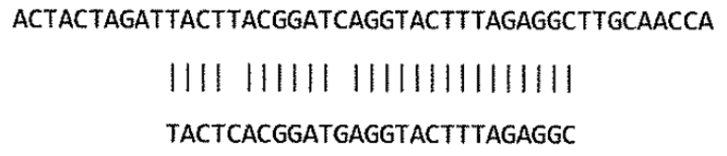

--------------------end of assignment #3--------------------

